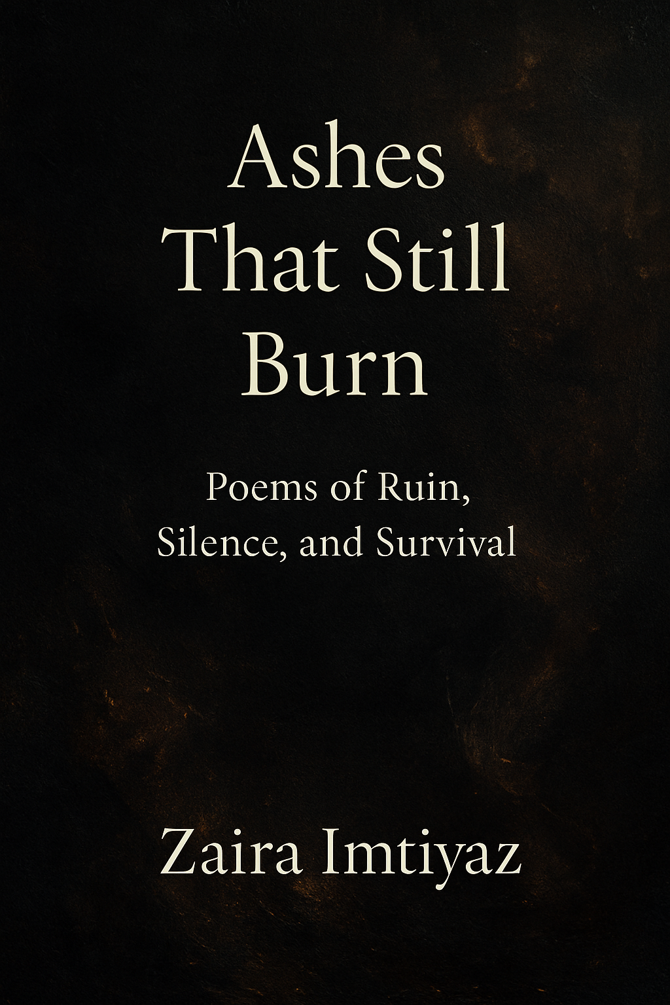
Note from the author
Dear Reader,
These poems are pieces of my heart, woven from moments of light and shadow, of hope and despair. Each verse carries a fragment of thought I once held quietly, now shared with you through these pages. My only wish is that while reading, you find reflections of your own journey comfort, recognition, or even questions that lead you deeper into yourself.

Thank you for holding this book in your hands. May it speak to you in ways beyond words.

With warmth,
Zaira Imtiyaz

Table of content

1. The Anatomy of Vanishing

2. Cathedral of Her Silence

3. The Gospel of Rot
4. The cartography of her silence
5. Machinery of Bones

6. The Weight of Dust
7. Insensitivities
8. The archivist of ashes

The Anatomy of Vanishing
I strip my feelings bare by speaking them aloud, it swallows the marrow of my bones and leaves me echoing in rooms I cannot name.
I was born with a hunger for tenderness , a thirst so violent it cracked the vessel of my chest; to love, to give, to scatter warmth like ash over the ruins of myself.
Yet my pitiful mania for analysis
Erodes me like a rat in the rafters.
I doubt even my doubt,
I tear it apart until it withers, and in the end there is nothing left but the cruelty of over knowing.
I hate rarely, but when I hate, I become poisonous . My rage is not fire it is ice sharp enough to sever breath from throat.
Pardon me, pardon me
for the sins of survival. What must I reck in myself to remain standing? What hideous bargain must I strike with despair just to see another morning?
I am turning numb, a piano with sealed keys Once I was full of storm, now I am only the silence after thunder. Even my anger has grown brittle, like bones beneath forgotten earth.
I could have built pyramids with the effort it takes to hold my own weight, to convince my trembling hands that life is not a stone too heavy for them.
And still, some nights I rise against myself, building and collapsing in the same breath, a monument of exhaustion.
When the last of me is spent , i shall disappear not as a gesture, but as a truth a vanishing, a dissolving into air so thin no one can follow.
But until then,
I remain a burning witness to my own unraveling, half ghost, half flame, aching for a love that does not diminish me, aching for a silence that does not erase me

Cathedral of Her Silence
She is not just a women,
She is a force that unravels the air around her.. In her silence there is a weight, like the earth remembering every grave it has swallowed.
She carries loyalty like a scar,
truth like a weapon hidden beneath her ribs. Even her tenderness cuts not because it wounds, but because it reveals the smallness of everything else.
When she loves, the world bends to accommodate.
It is not the gentle rhythm of ordinary affection, but the violence of resurrection. She turns ruin into shelter, emptiness into cathedral.
I have watched her move through darkness, not untouched, but unbroken.
The serpent that coils around others lies quiet at his throat, tamed by the gravity of her being.
She is not salvation,she is the certainty that salvation is possible. In her gaze, the fragments of me recognize themselves as whole.
Call it strength if you must, but strength is too pale, too fragile a word. What she is, is proof that even the shattered can worship without kneeling.
And if you follow her silence closely, you will find it is not emptiness, but the hymn of survival itself.

The Gospel of Rot
There is no grave deep enough for the faith I once carried
I unstitched the loyal creature from my ribs,
watched her obedience curdle into a stagnant pool, and in her silence I recognized servitude as a kind of disease I could no longer endure.
Truth was never a virtue, only a knife that begged for a throat. I held my own against the current, submerged her beneath the lake of my blood, the surface trembling with bubbles of unfinished confessions.
Her eyes were still open when I let go.
Childhood was the cruelest illusion that fragile specter who thought light could be kept. I crushed her skull like a clay vessel, scattered her small bones among the ruins of my laughter, and turned away before the last echo could reach me.
Now a serpent winds itself around my throat, its body the only necklace I deserve.
I breathe in venom as prayer, I carry rot as gospel. The flesh that walks is not a self but the residue of massacres.
And yet in the rot, there is truth more honest than purity for what decays cannot lie, it only reveals what was always there.
Evil is not what I became it is what remained after every version of me was executed, their corpses stacked in the corners of my soul, waiting for the day I join them.

The Cartography of Silence
Silence is no longer absence.
It has grown teeth.
It stalks me down corridors where language should have lived, and every word I never spoke calcifies into monuments of regret.
I have charted its borders, mapped its hollow valleys, and yet each time I walk its terrain I lose myself again, a pilgrim in a temple where prayer is only breath withheld.
But silence is not only exile sometimes it is preservation. Sometimes the unsaid protects me from being consumed by the cruelty of knowing.
If silence is a map, then I am its compass, forever pointing nowhere.
And in that nowhere, a strange peace lingers, not the peace of freedom, but the peace of surrendering to what cannot be spoken.

Machinery of Bones
I no longer move from will, but from the stubborn inertia of being alive. My body is a factory, its bones clanging like iron beams, its blood a conveyor belt dragging me from day to day.
I smile when required, I nod when expected, but beneath the performance is the mechanical grind of a creature unwilling to collapse only because collapse requires energy I do not possess.
Yet sometimes, in the creak of my ribs, I hear rebellion.
What if the machine refuses? What if the only freedom left is to rust deliberately?
And if I rust, let it be visible, let the world see the cost of existing on nothing but broken gears.

The Weight of Dust
Dust is the only inheritance I trust. It gathers on books, on memories, on the ridges of my face.
It gathers even when I beg for stillness.
Dust is patient. It does not strike, it waits̶ a soft assassin covering everything I thought was permanent.
But there is a strange mercy in dust. It softens sharp edges, cloaks wounds in a quiet veil, reminds me that even grief can be reduced to something weightless.
When I am dust,
let me be stubborn the kind that lingers on windowsills, defying every attempt to sweep it away.
For dust is also memory, and memory is the only proof that I once disturbed the air.

Insensitivities
Once I bled at the sight of suffering, every bruise was a scripture I carried in my chest. Now I walk through wreckage as if it were furniture.
I do not flinch when voices crack, I do not tremble at tears. Even the graves seem ornamental, their sorrow dulled into shapes of stone.
Do not mistake me for cruel.
Cruelty requires intention. This is not malice, this is erosion the heart wearing down until it no longer recognizes heat or cold.
There was a time I envied water, how it could mirror every sky. Now I envy stone untouched by weather, silent even when the storm beats against it.
They call me unfeeling, but I am not without feeling.
I am the carcass of feelings once sharpened too violently, a husk that survives only because
sensitivity became unbearable.
If numbness is a crime, then I plead guilty. But guilty or not, it is the only way I still remain standing.

The Archivist of Ashes
I collect what others discard. Every broken attempt, every failed gesture, every fracture too small to be named I archive them in secret shelves inside my ribs.
Do not call it obsession.
This is my covenant with memory. If no one else remembers the ruins, then I will.
Yet there is a light here too. Ashes, when pressed together, still carry the warmth of what once burned. To archive is not only to mourn, but to declare: this flame existed, and in its brief existence it was enough to alter the air.
And if one day I vanish, let my archives remain, a testament that I was not silent, I was only fire slowed into ash.

About the Author

Zaira Imtiyaz is a young student born and brought up in kashmir who finds solace in words and rhythm. Through poetry, she transforms fleeting emotions into lasting expressions, giving voice to thoughts that often remain unspoken.

Her writing reflects both vulnerability and strength, drawing from everyday experiences, quiet reflections, and deep questions about life. As a student, she continues to learn not only from books but from the world around her believing that poetry is the bridge between the heart and the mind.

This collection is her invitation for readers to pause, feel, and discover parts of themselves hidden within the verses.

